John Carroll

Comp 3700

Homework 2

9/5/2015

1. 5.3  
   
2. 5.4



1. 5.5  
   
2. 6.7

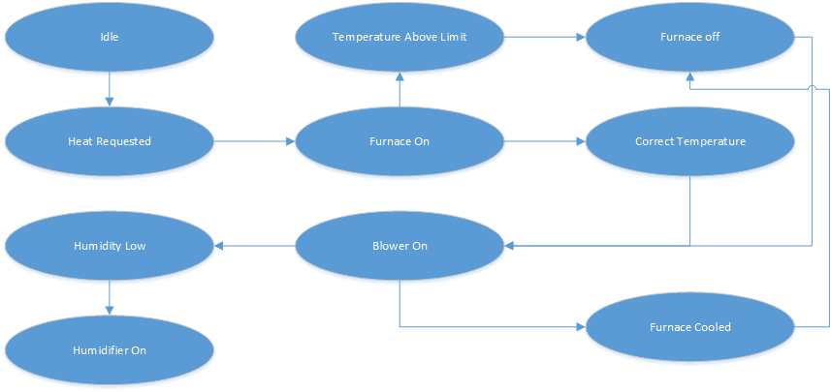

1. 6.10  
   